Post Upgrade Customization Deployment - RH1
Schindler CRD Applications

Exported on 2025-08-19 05:09:03

Table of Contents

No table of contents entries found.

- Article Referred: Article - CS446313 - How to run the com.ptc.core.lwc.server.EnumeratedTypeCustomizationMigrator utility in Windchill PDMLink
Migrate custom RB file entries to Modeled Enumerations
- Take backup of all OOTB modified Modelled enumeration
- Create ExportModeledEnum.xml with below content. (File is available in attachment)
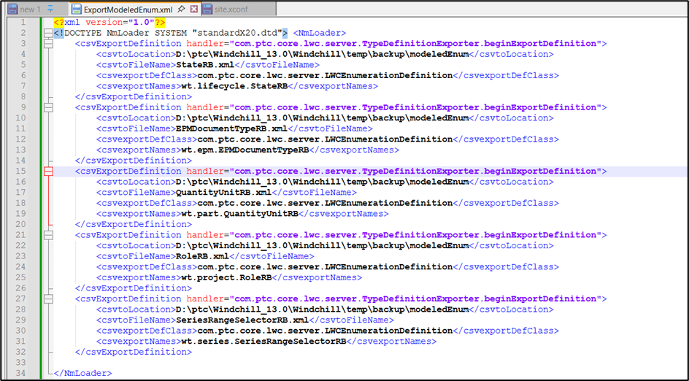

3. Run below command in windchill Shell
windchill wt.load.LoadFromFile -d D:\ptc\Windchill_13.0\Windchill\temp\backup\modeledEnum\ExportModeledEnum.xml -u wtadmin -p <password>
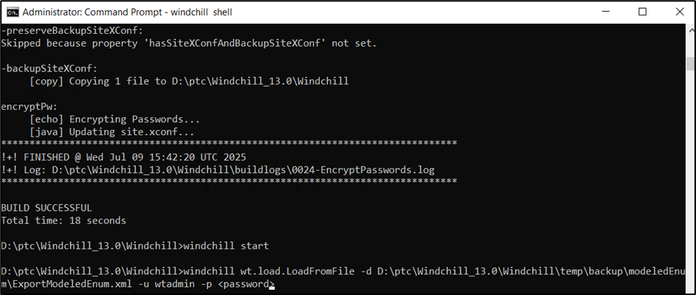

4. Copy wtCustom package in <WC_HOME> directory
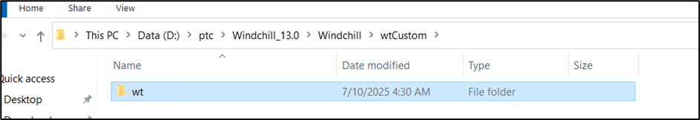

5. Run below command from windchill shell to migrate custom rbinfo files entries
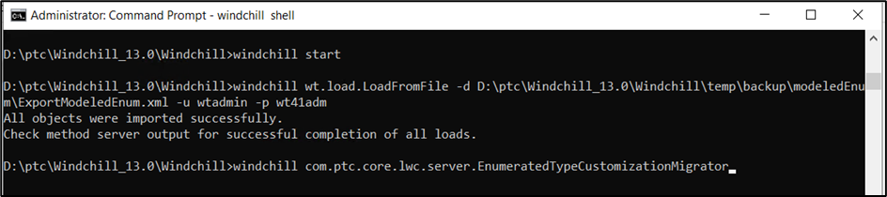

6. Enter wtadmin credentials
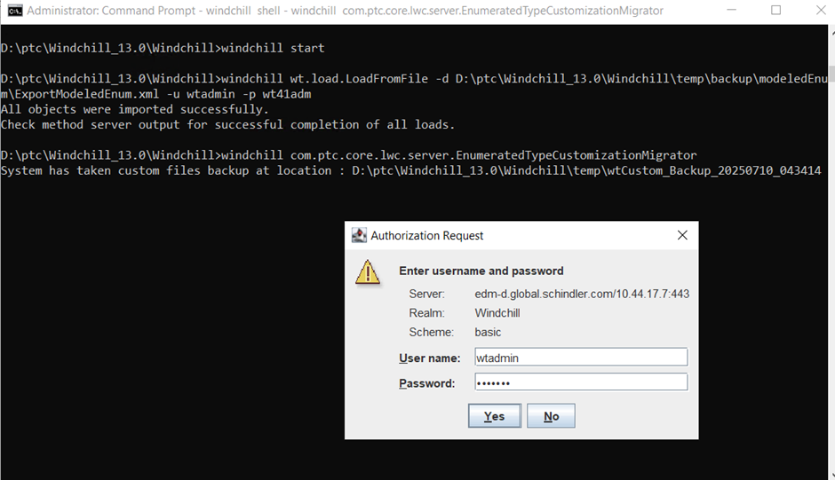
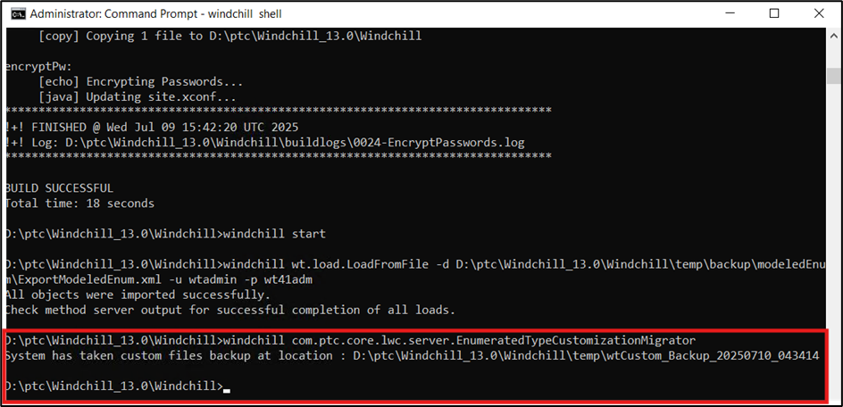

7. Validate there are no error reported in logs
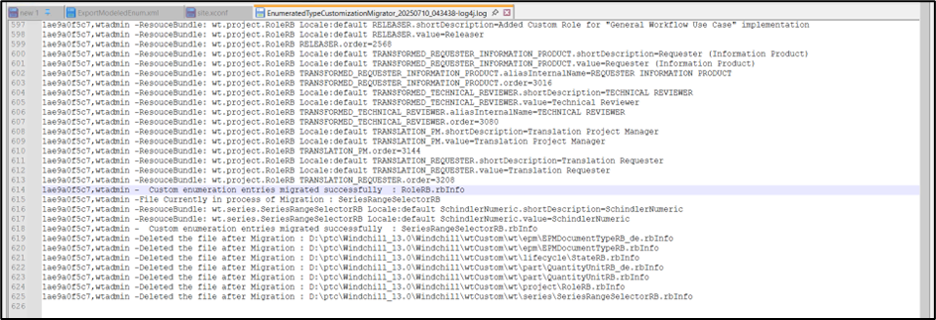

8. Navigate to Site > Utilities > Type and Attribute Management > Customize Modelled Enumeration and Validate the custom entries
